**COP3813-003 (Fall 2018)**

**PROJECT 4**

**Google Analytics & Website Tour**

**Name: Alicia Mitchell**

**Due: 11/25/18**

**Google Analytics Admin Data**

**URL:** [**http://lamp.cse.fau.edu/~amitch41/p4/**](http://lamp.cse.fau.edu/~amitch41/p4/)

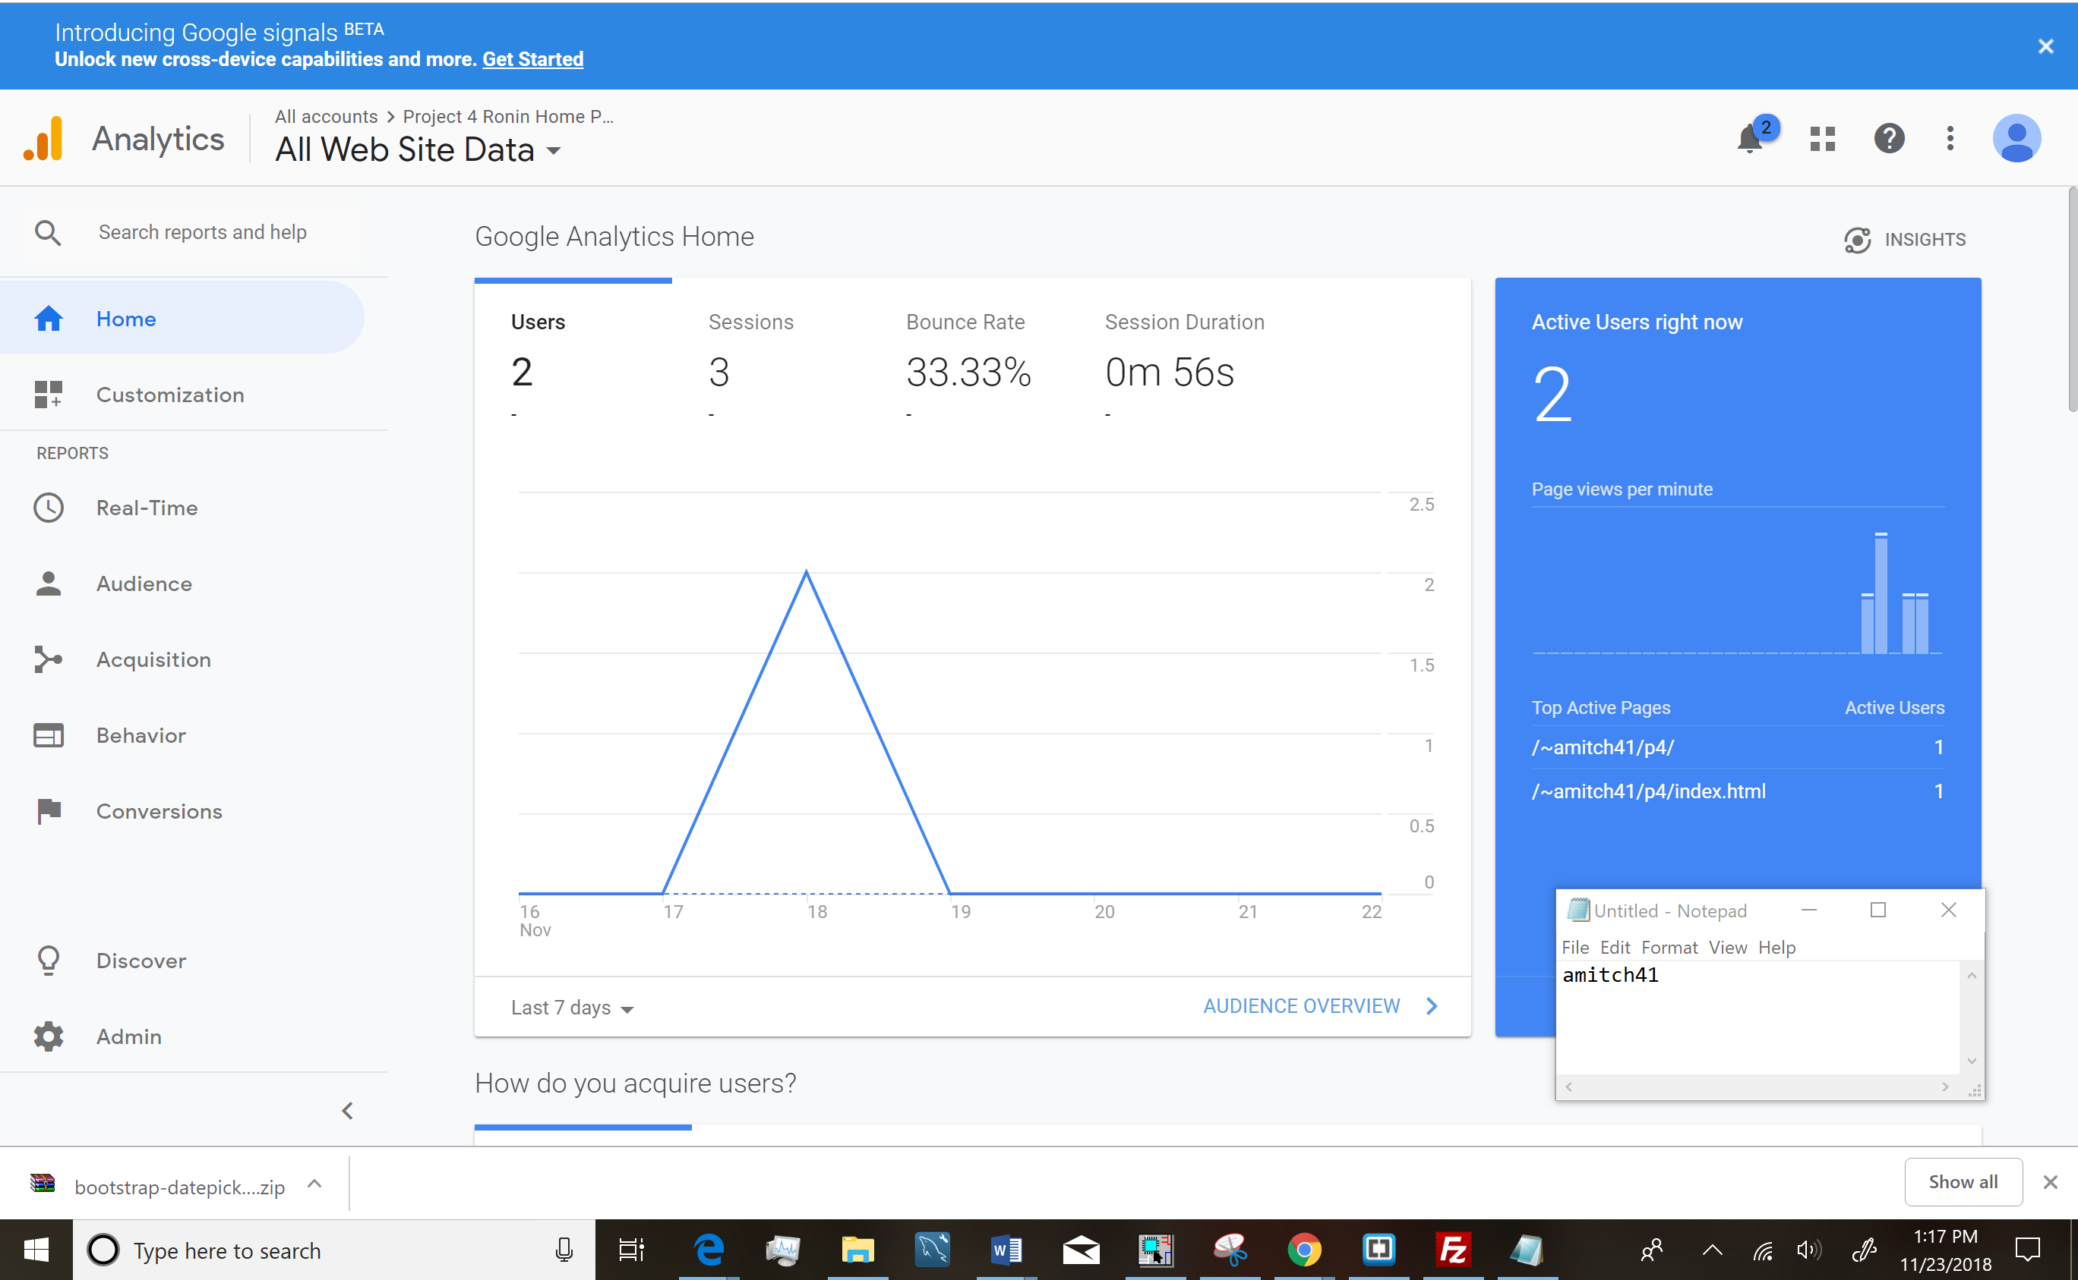

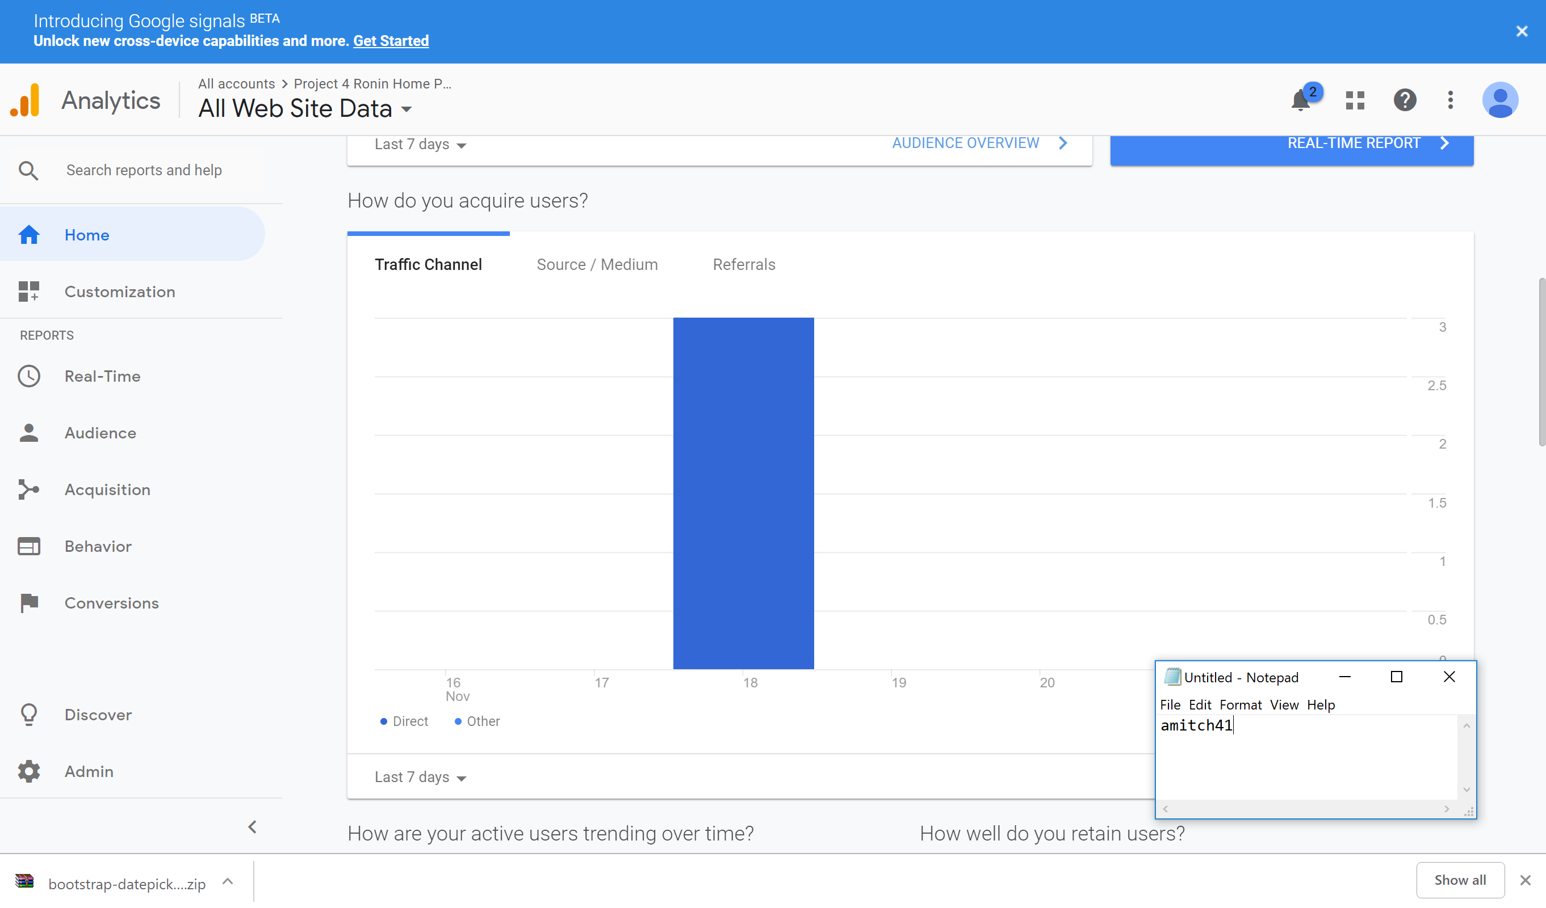

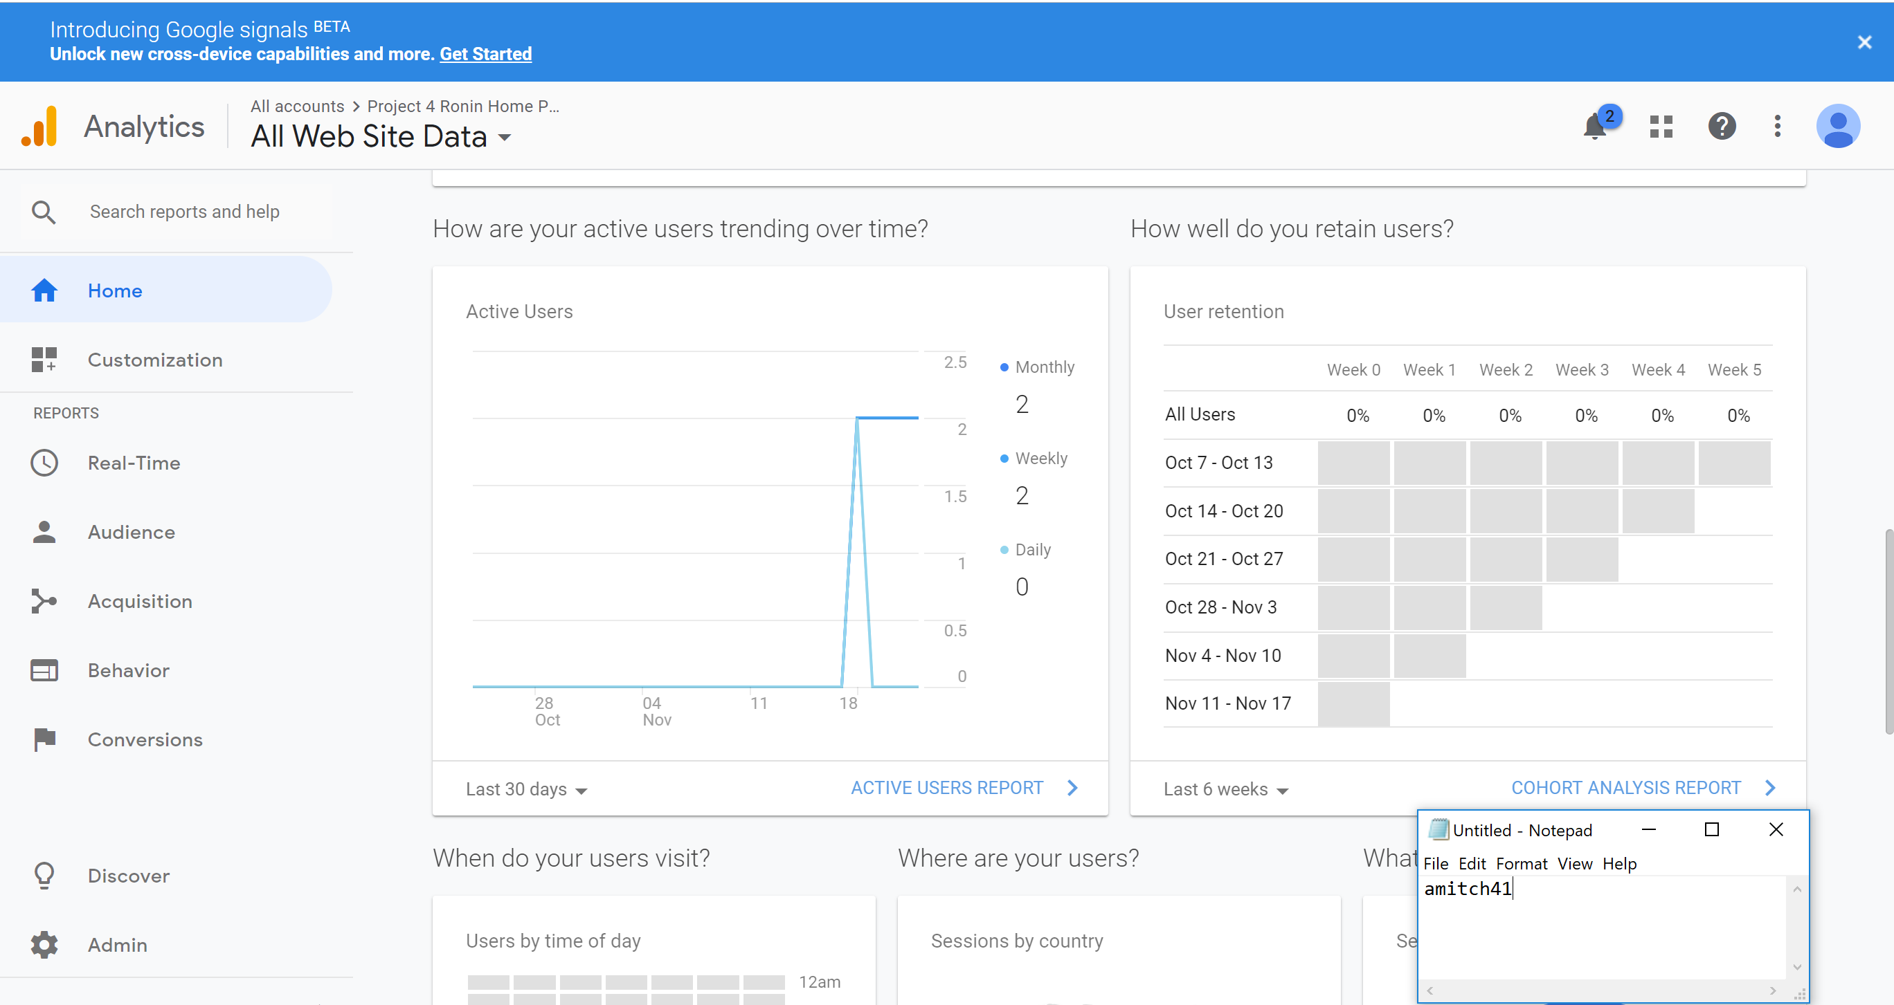

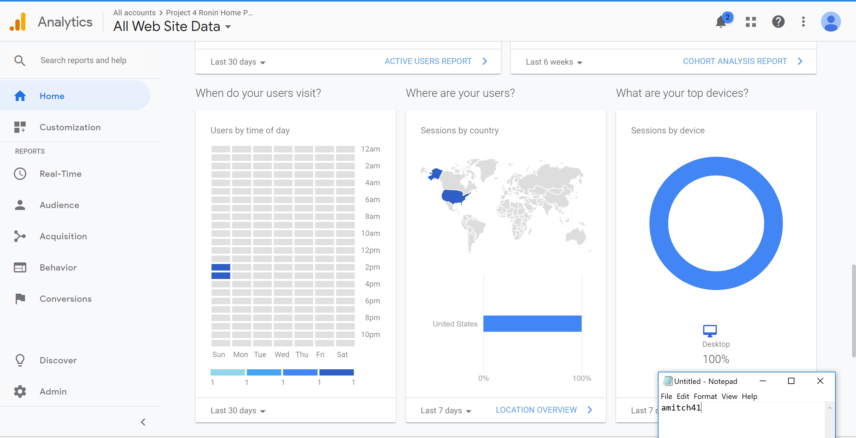

**Website Tour of New Dynamic Features**

**Sending a message via contact us page**

1. Navigate to [**http://lamp.cse.fau.edu/~amitch41/p4/**](http://lamp.cse.fau.edu/~amitch41/p4/)

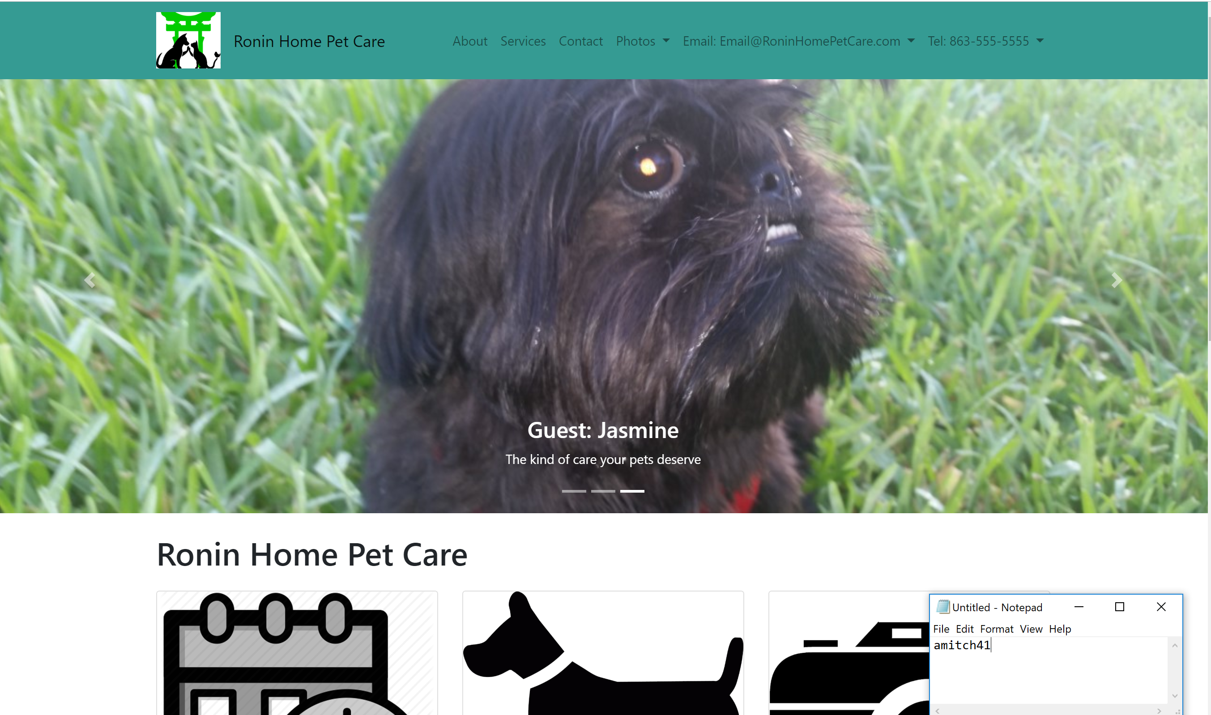

1. Select the Contact option on the Navbar

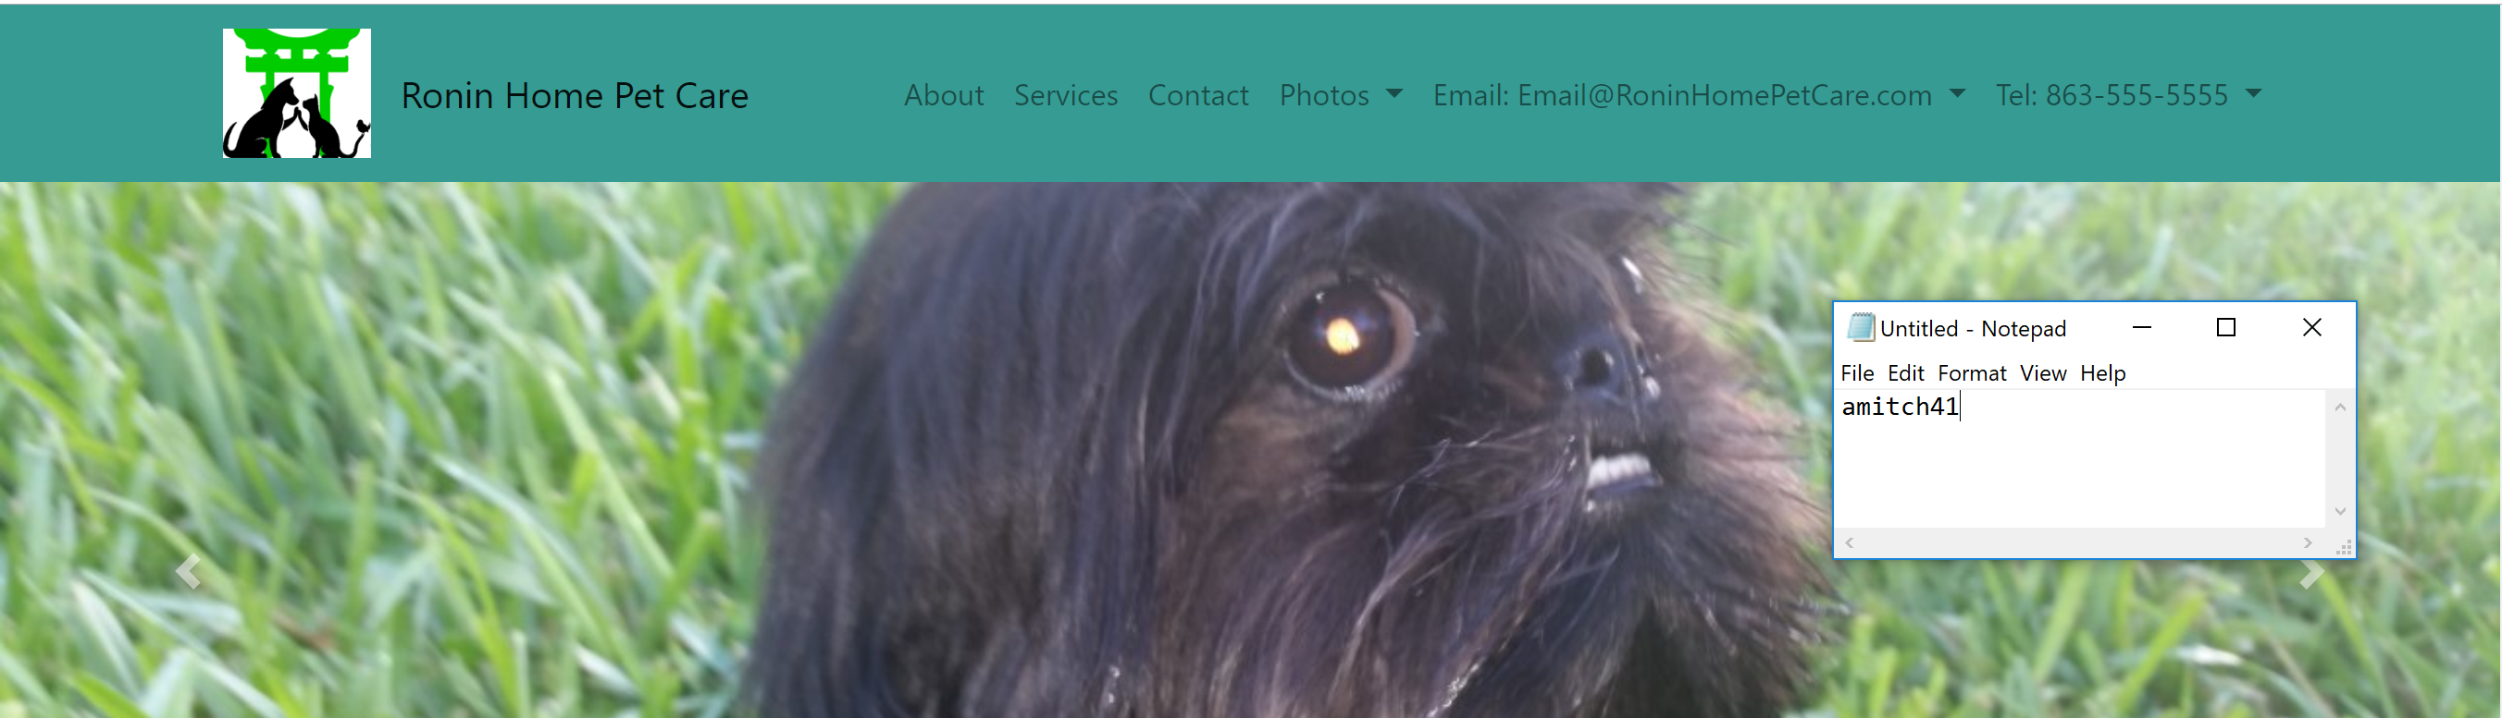

1. Complete the contact us form

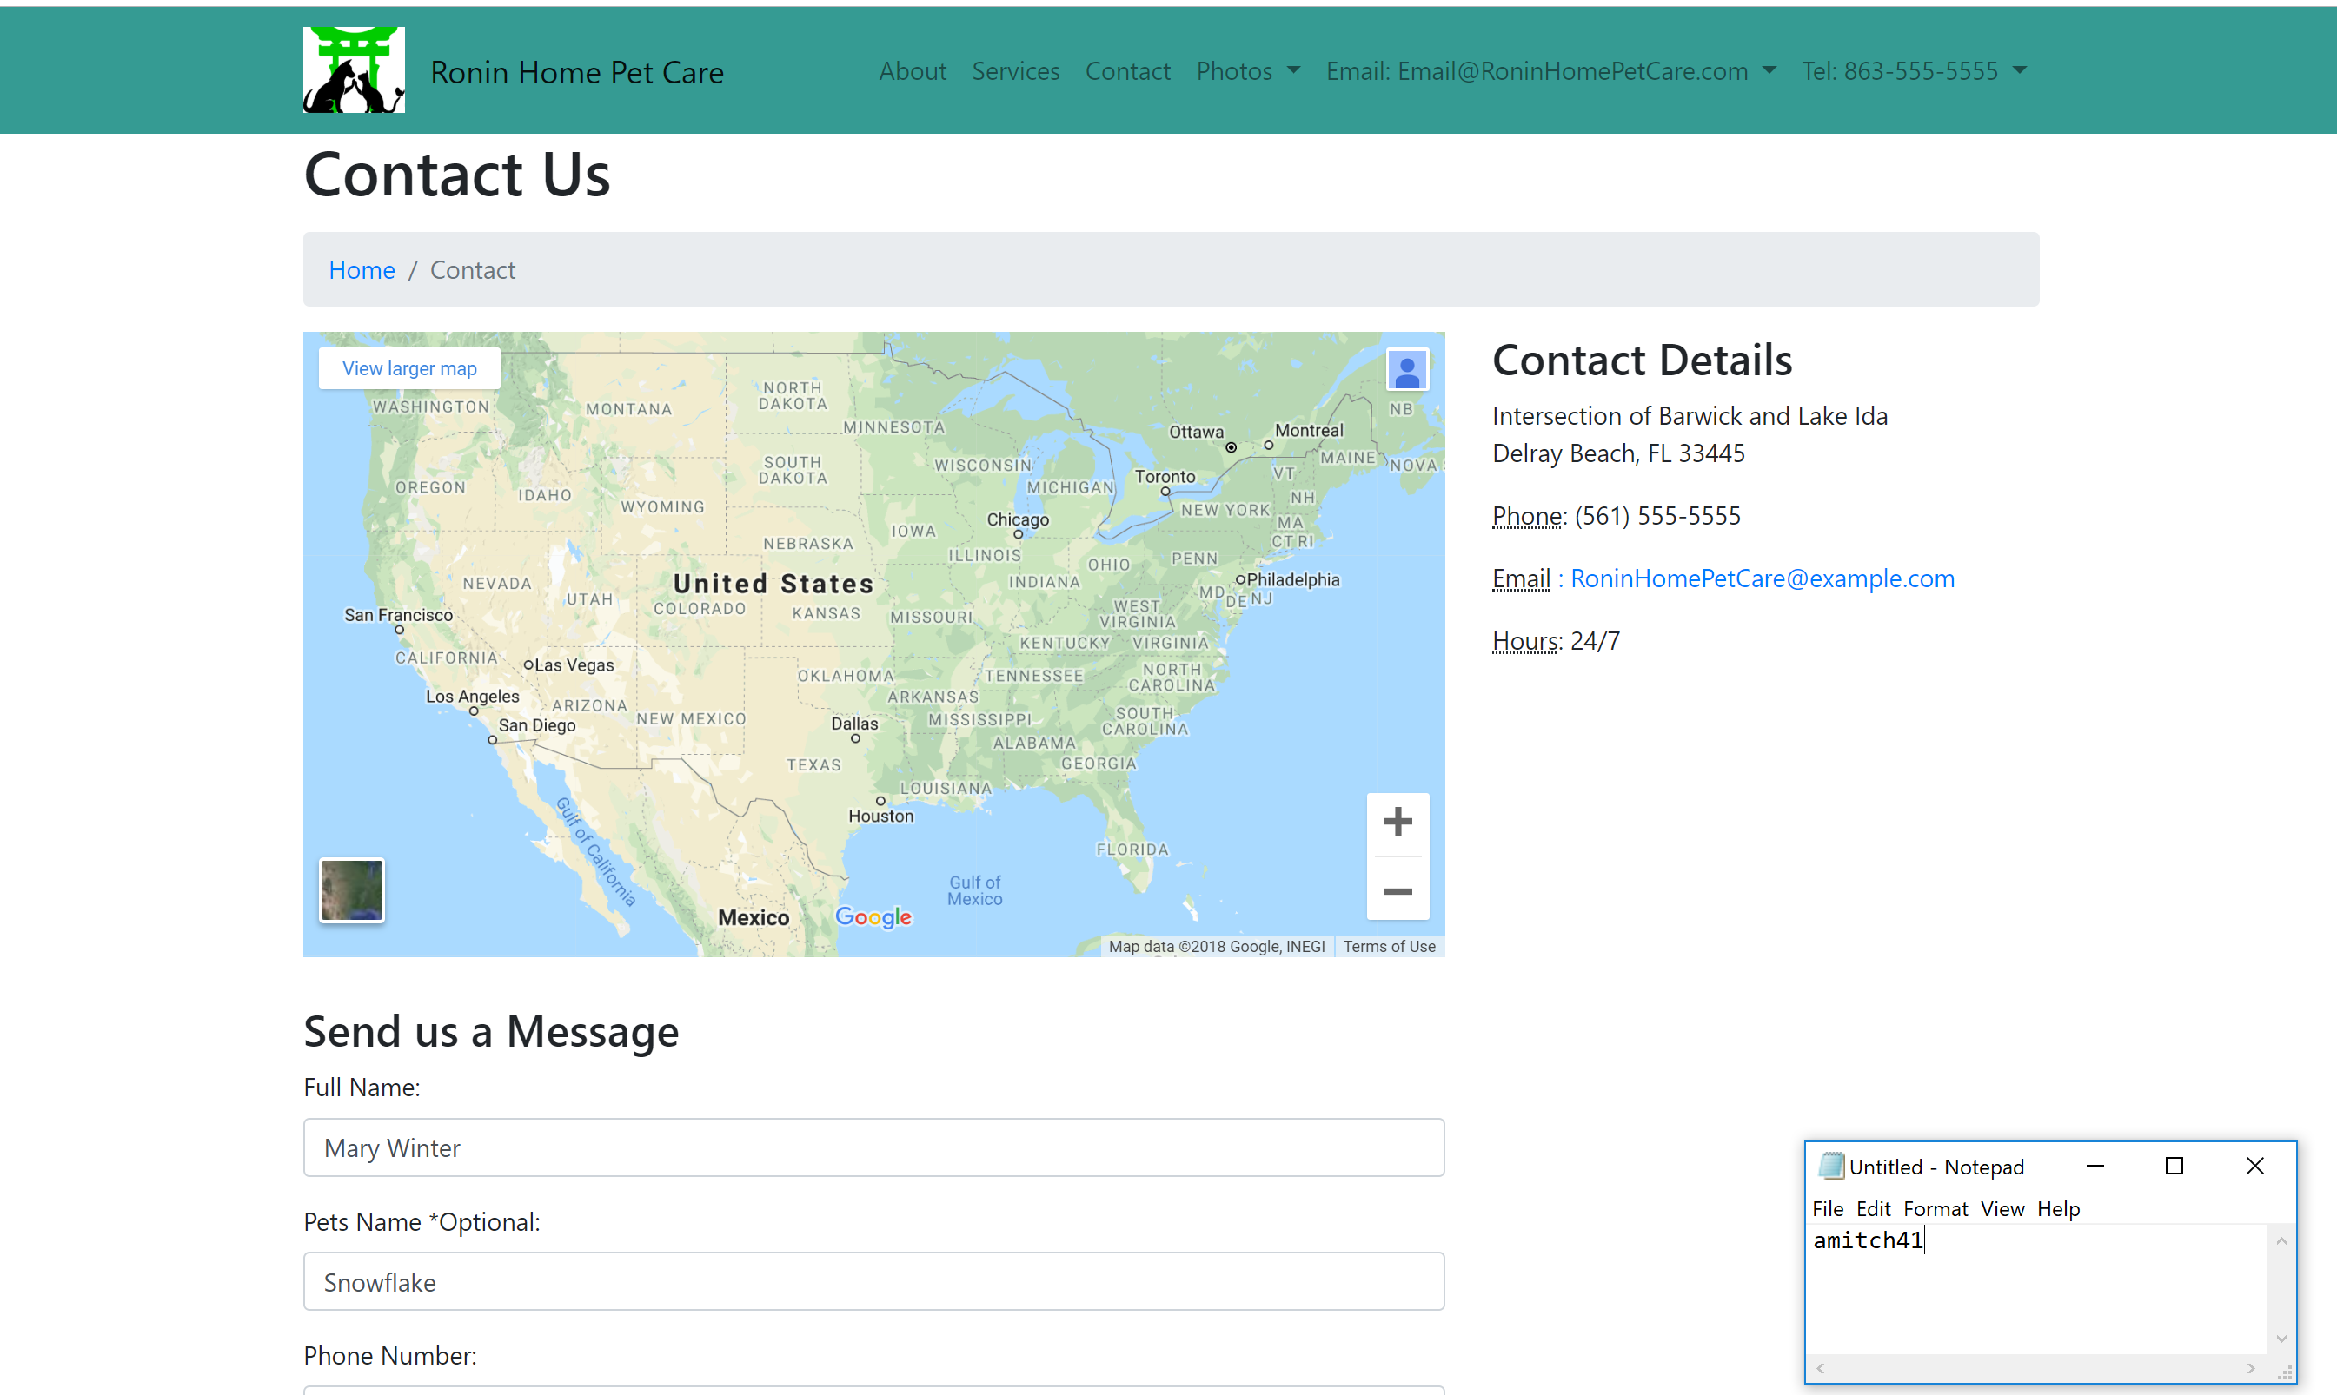

1. Click on the Send Message button

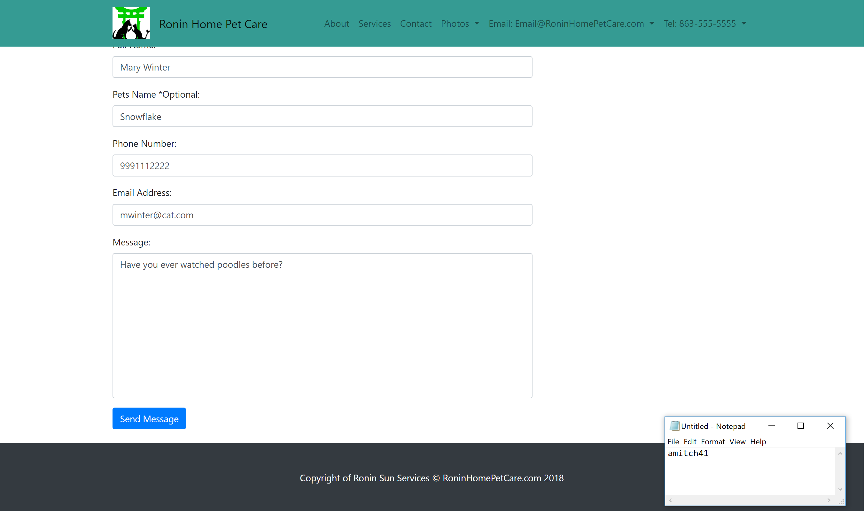

1. Then you will be brought to the confirmation page

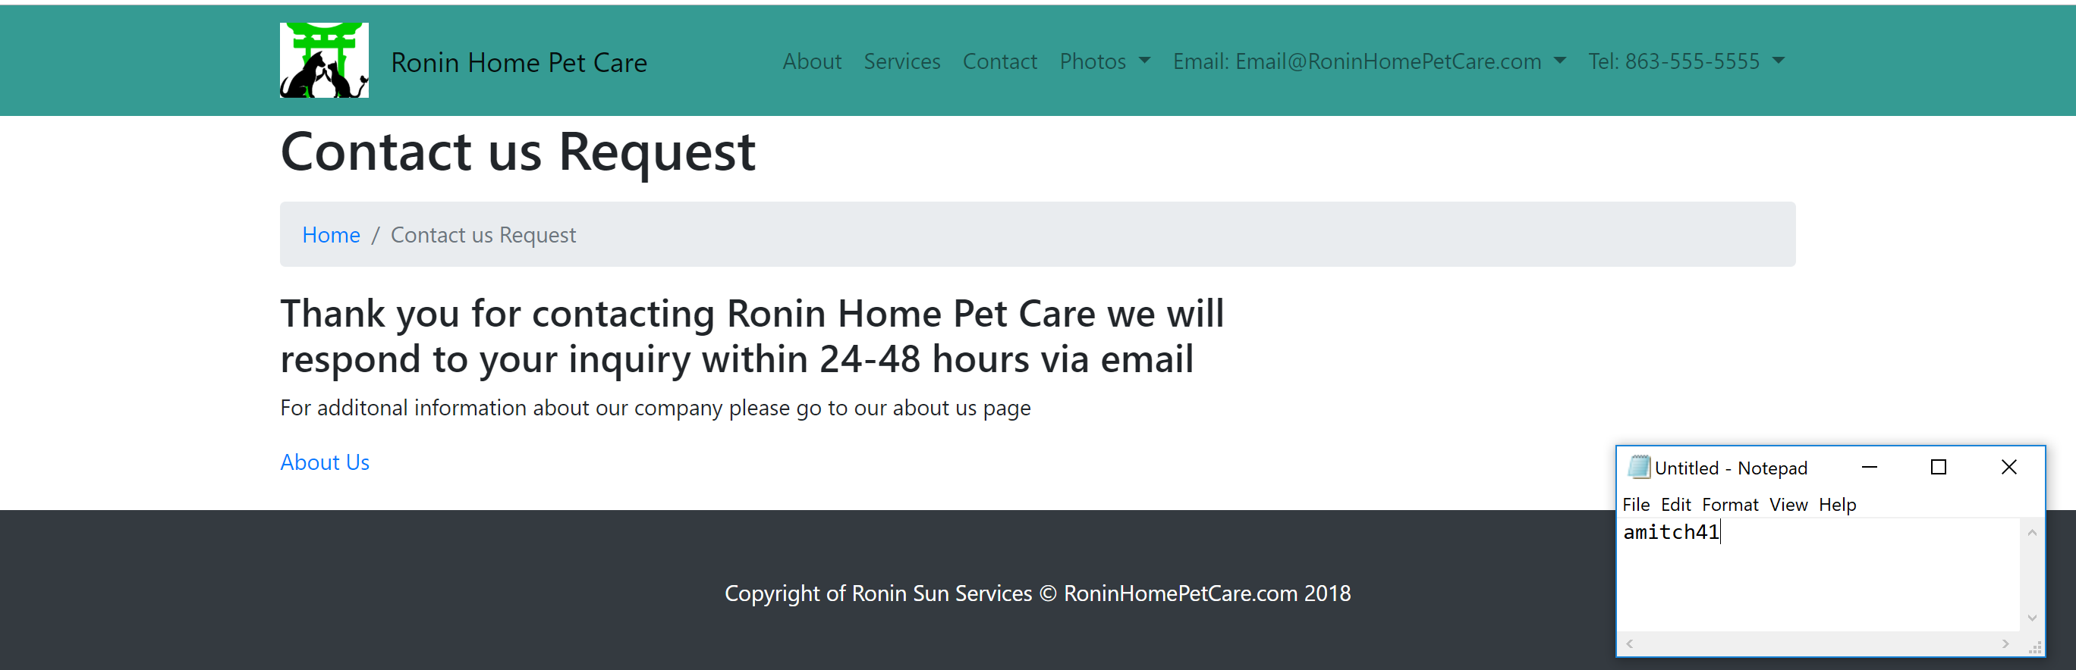

1. Behind the scenes a new entry has been entered into the database

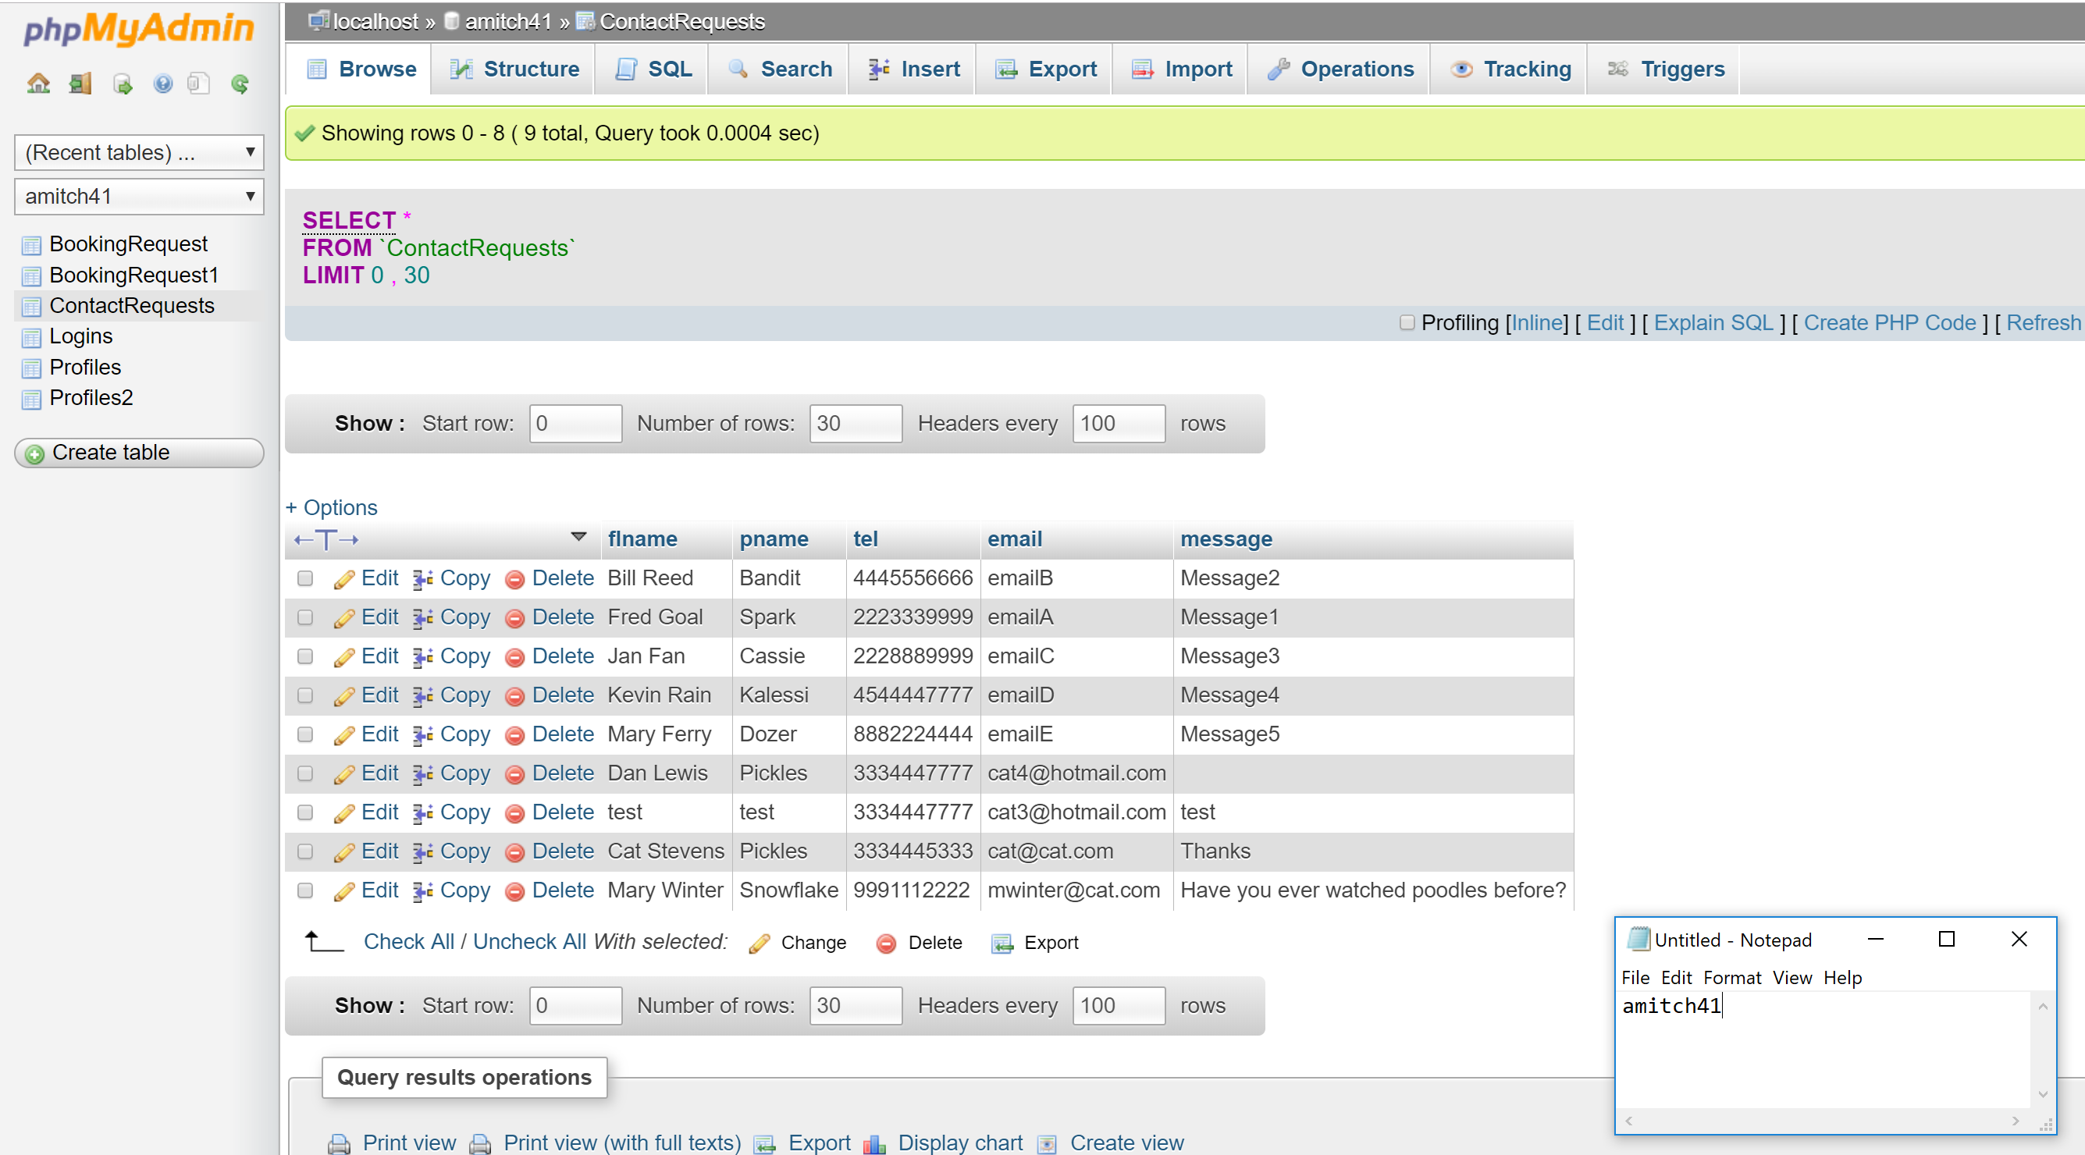

1. An email has been sent after the form has been submitted

*Note all emails are sent to my personal email

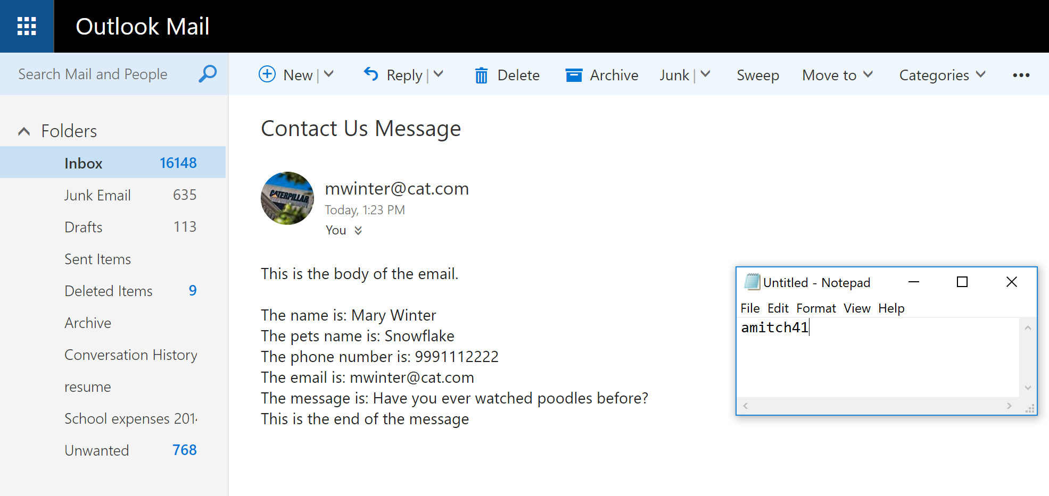

**Making a booking request**

1. Select the Service option on the Navbar



1. Complete the booking request form

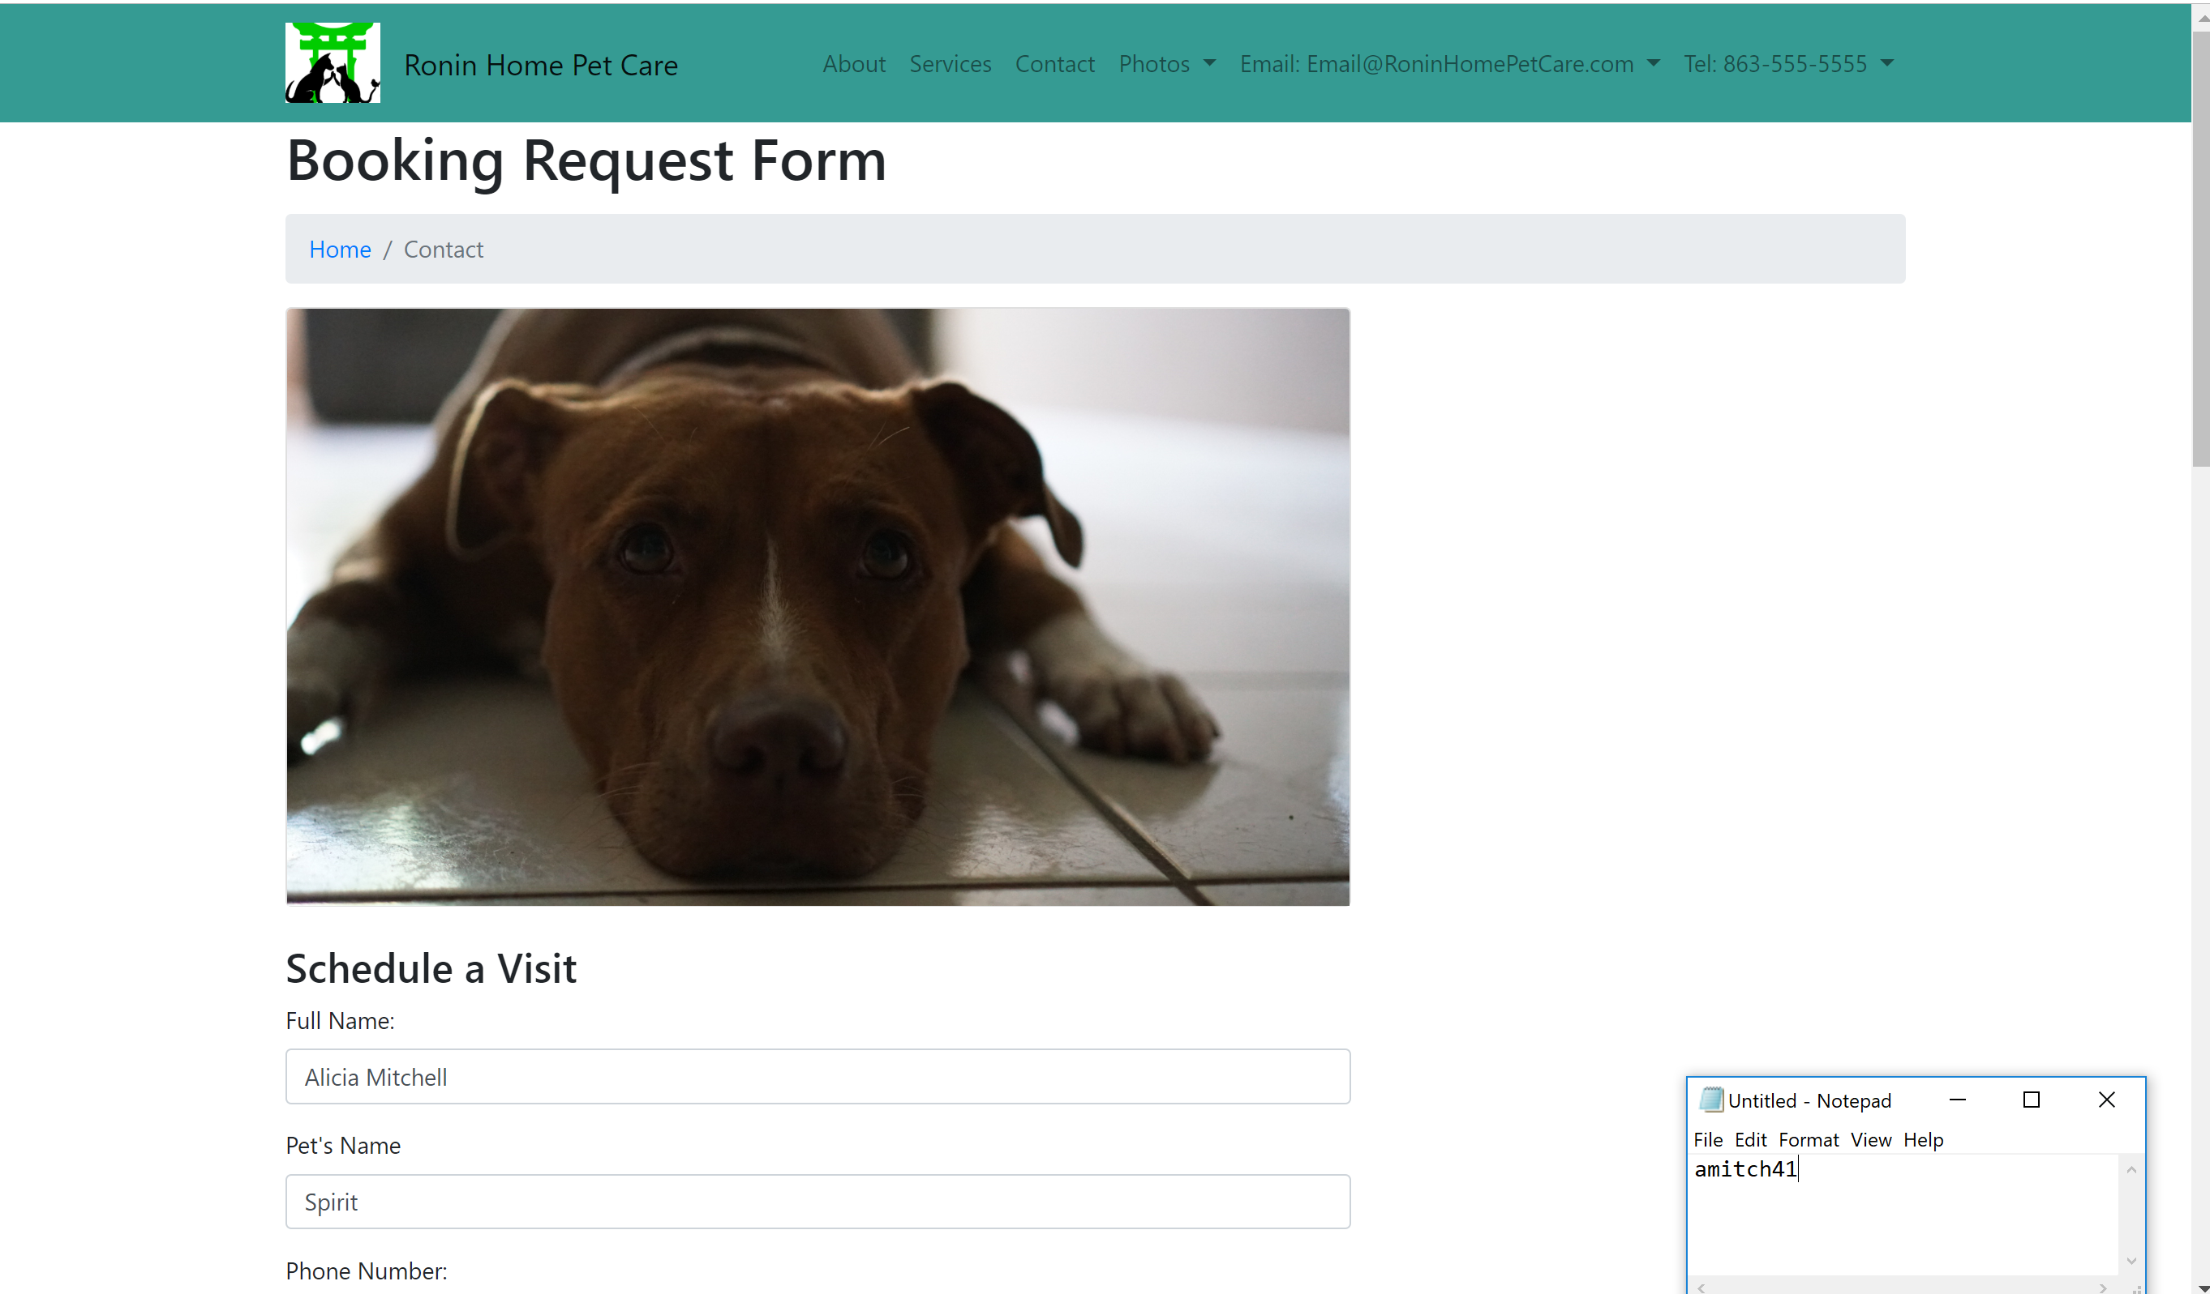

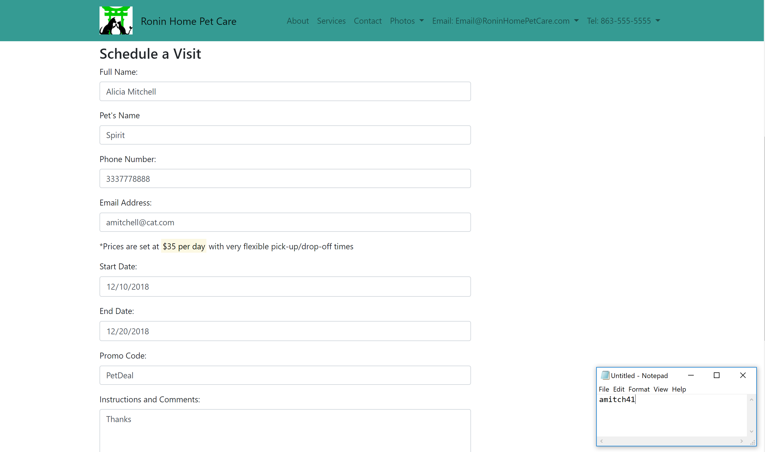

1. Click the Book it button

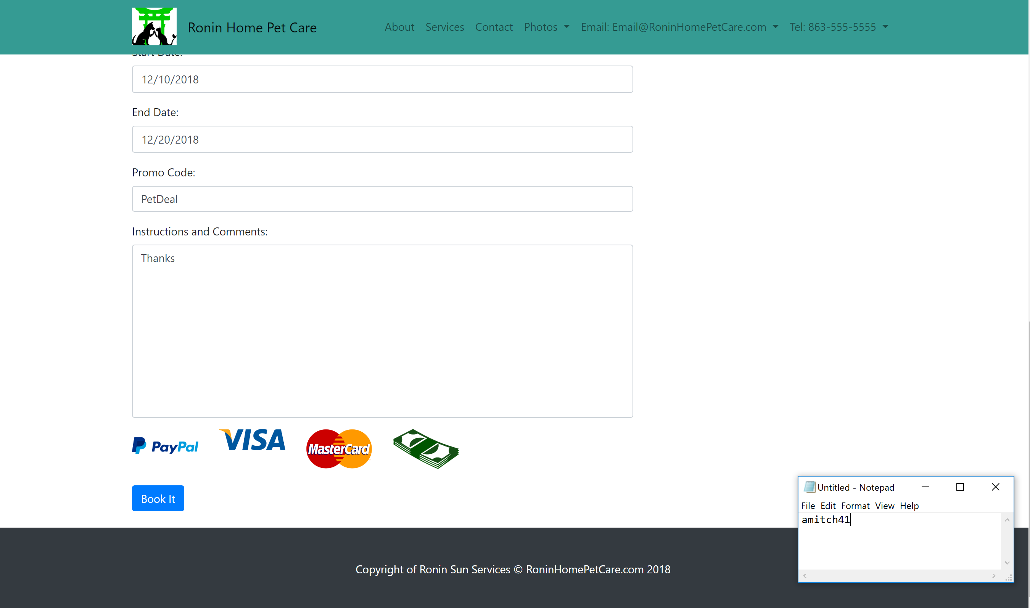

1. Then you will be brought to the confirmation page

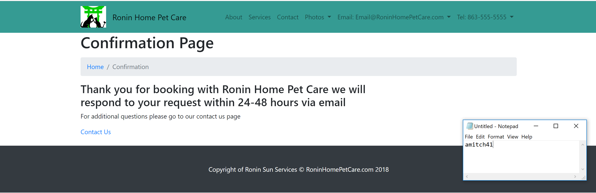

1. The database is updated accordingly with the new entry

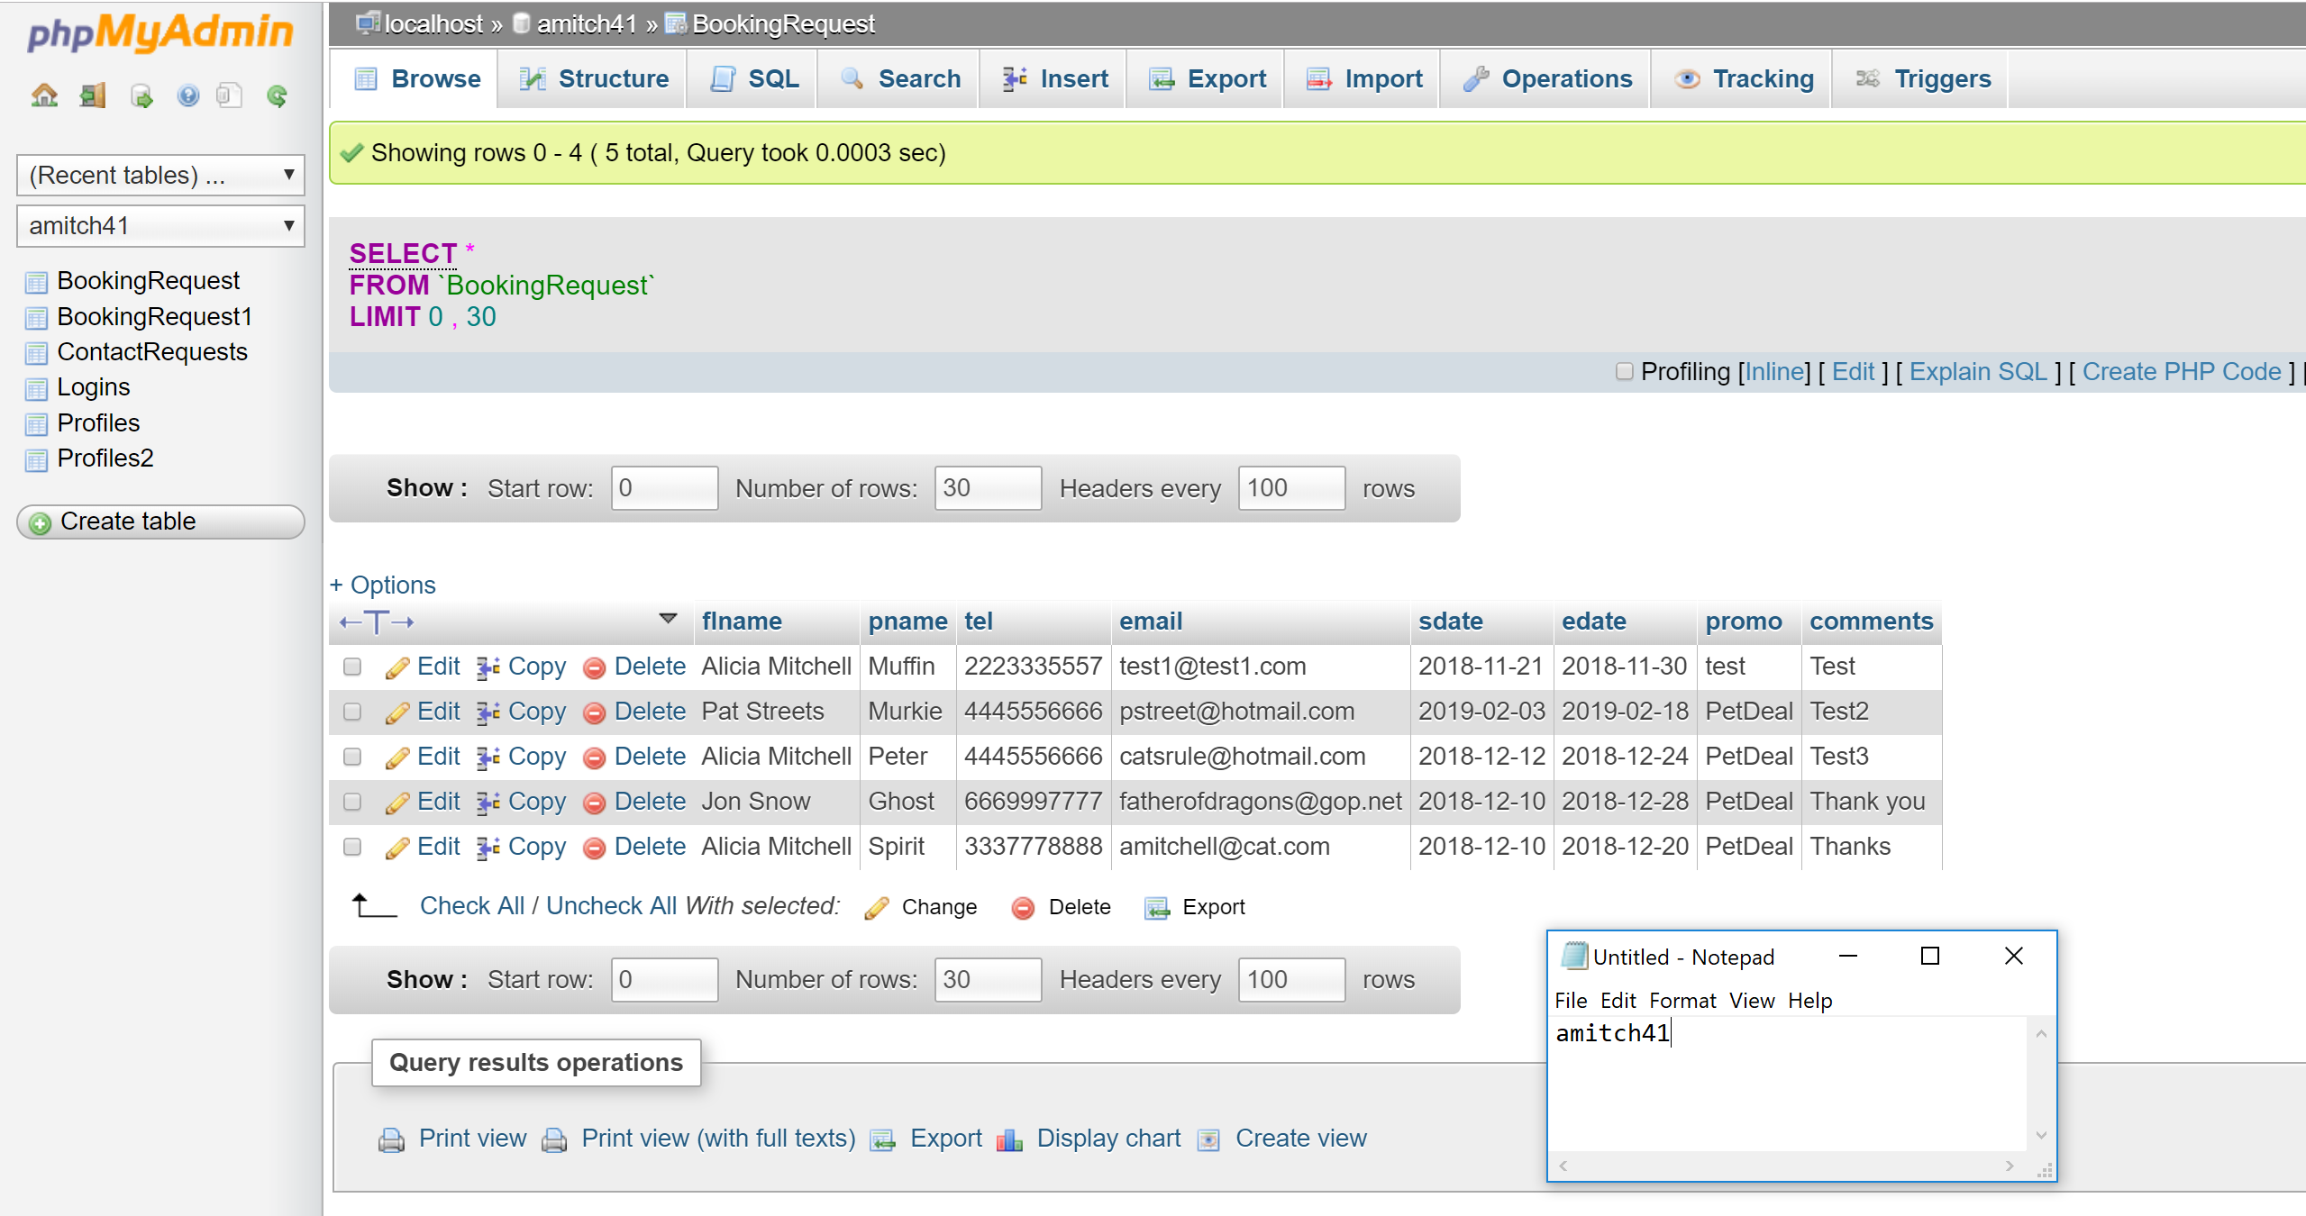

1. An email is also sent to reflect the booking request

*Note all emails are sent to my personal email

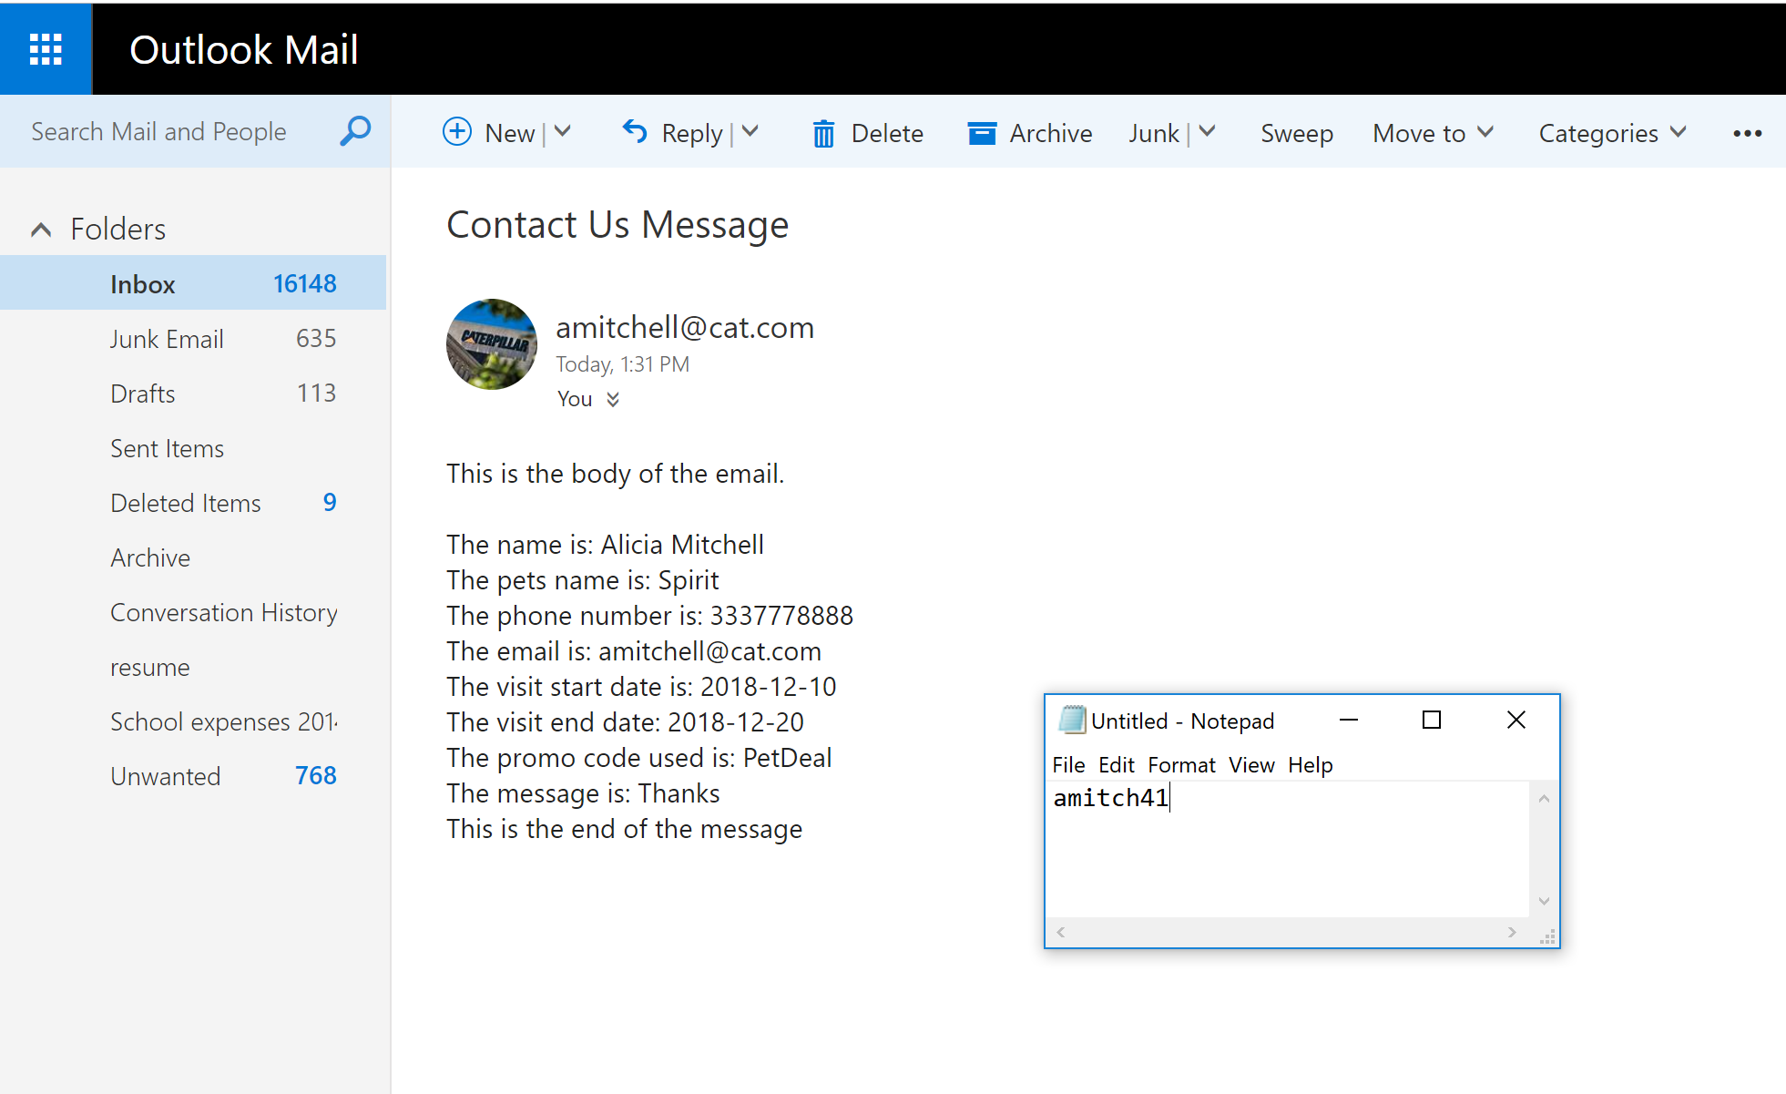

**Admin Viewing a booking request**

1. Navigate to the Admin Login via navbar option shown below

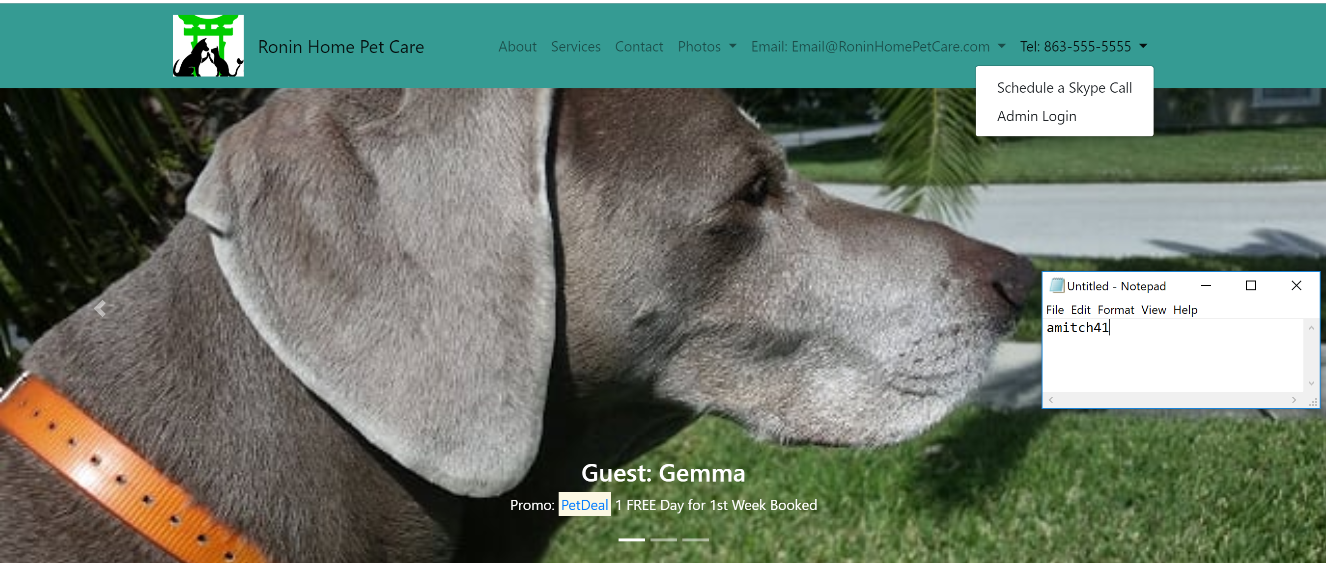

1. Login with the credential’s username: admin password: admin

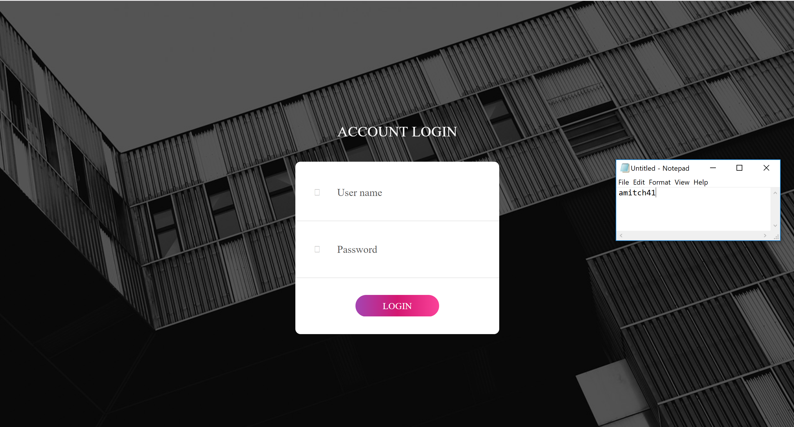

1. Once logged in it displays the Booking requests such as the one made in the demo example

